ONLINE COMPLAINT SUBMISSION
@CREATIVITY THINK (9483175986/7019689991)

ABSTRACT:
The Online Complaint Submission system is a web application designed to streamline complaint logging, tracking, and resolution. Users can submit complaints, monitor progress, receive notifications, and access dashboards for an overview of their submissions. Administrators can assign teams, resolve complaints, manage logs, and analyze complaint data through dashboards. Built with Django and Django Rest Framework on the backend and React with Redux and Axios on the frontend, the platform ensures secure handling of user data, efficient workflow management, and actionable analytics. This system enhances transparency, accountability, and responsiveness in complaint management..

INTRODUCTION OF THE PROJECT:
Managing complaints manually often leads to delays, miscommunication, and poor accountability. The Online Complaint Submission system addresses these challenges by providing a centralized web platform for logging, tracking, and resolving complaints. Users can monitor their submissions and receive real-time updates, while administrators manage teams, track resolution progress, and view analytical dashboards. Leveraging Django, Django Rest Framework, React, Redux, and Axios, the system delivers a secure, efficient, and user-friendly complaint management experience..

PROJECT OBJECTIVES:

• Enable users to submit and track complaints online
• Provide real-time status updates and notifications
• Allow administrators to assign teams and resolve issues efficiently
• Maintain detailed logs of all complaints
• Generate analytics dashboards for administrators
• Reduce response times and improve accountability
• Ensure secure handling of user and complaint data

PROBLEM OF THE STATEMENT:
Manual complaint management systems often result in lost reports, delayed responses, and lack of accountability. Users face difficulty tracking progress, while administrators struggle with organizing complaints, assigning teams, and analyzing resolution efficiency. The Online Complaint Submission platform addresses these issues by offering a centralized, web-based interface for submission, tracking, notifications, and administrative analytics, ensuring timely and transparent complaint resolution..

MOTIVATION OF THE PROJECT:
• Streamline complaint submission and management
• Provide transparency and accountability in issue resolution
• Enable real-time tracking for users
• Facilitate efficient administrative assignment and monitoring
• Offer analytics for performance and complaint trends

BLOCK DAIGRAM OF PROJECT:

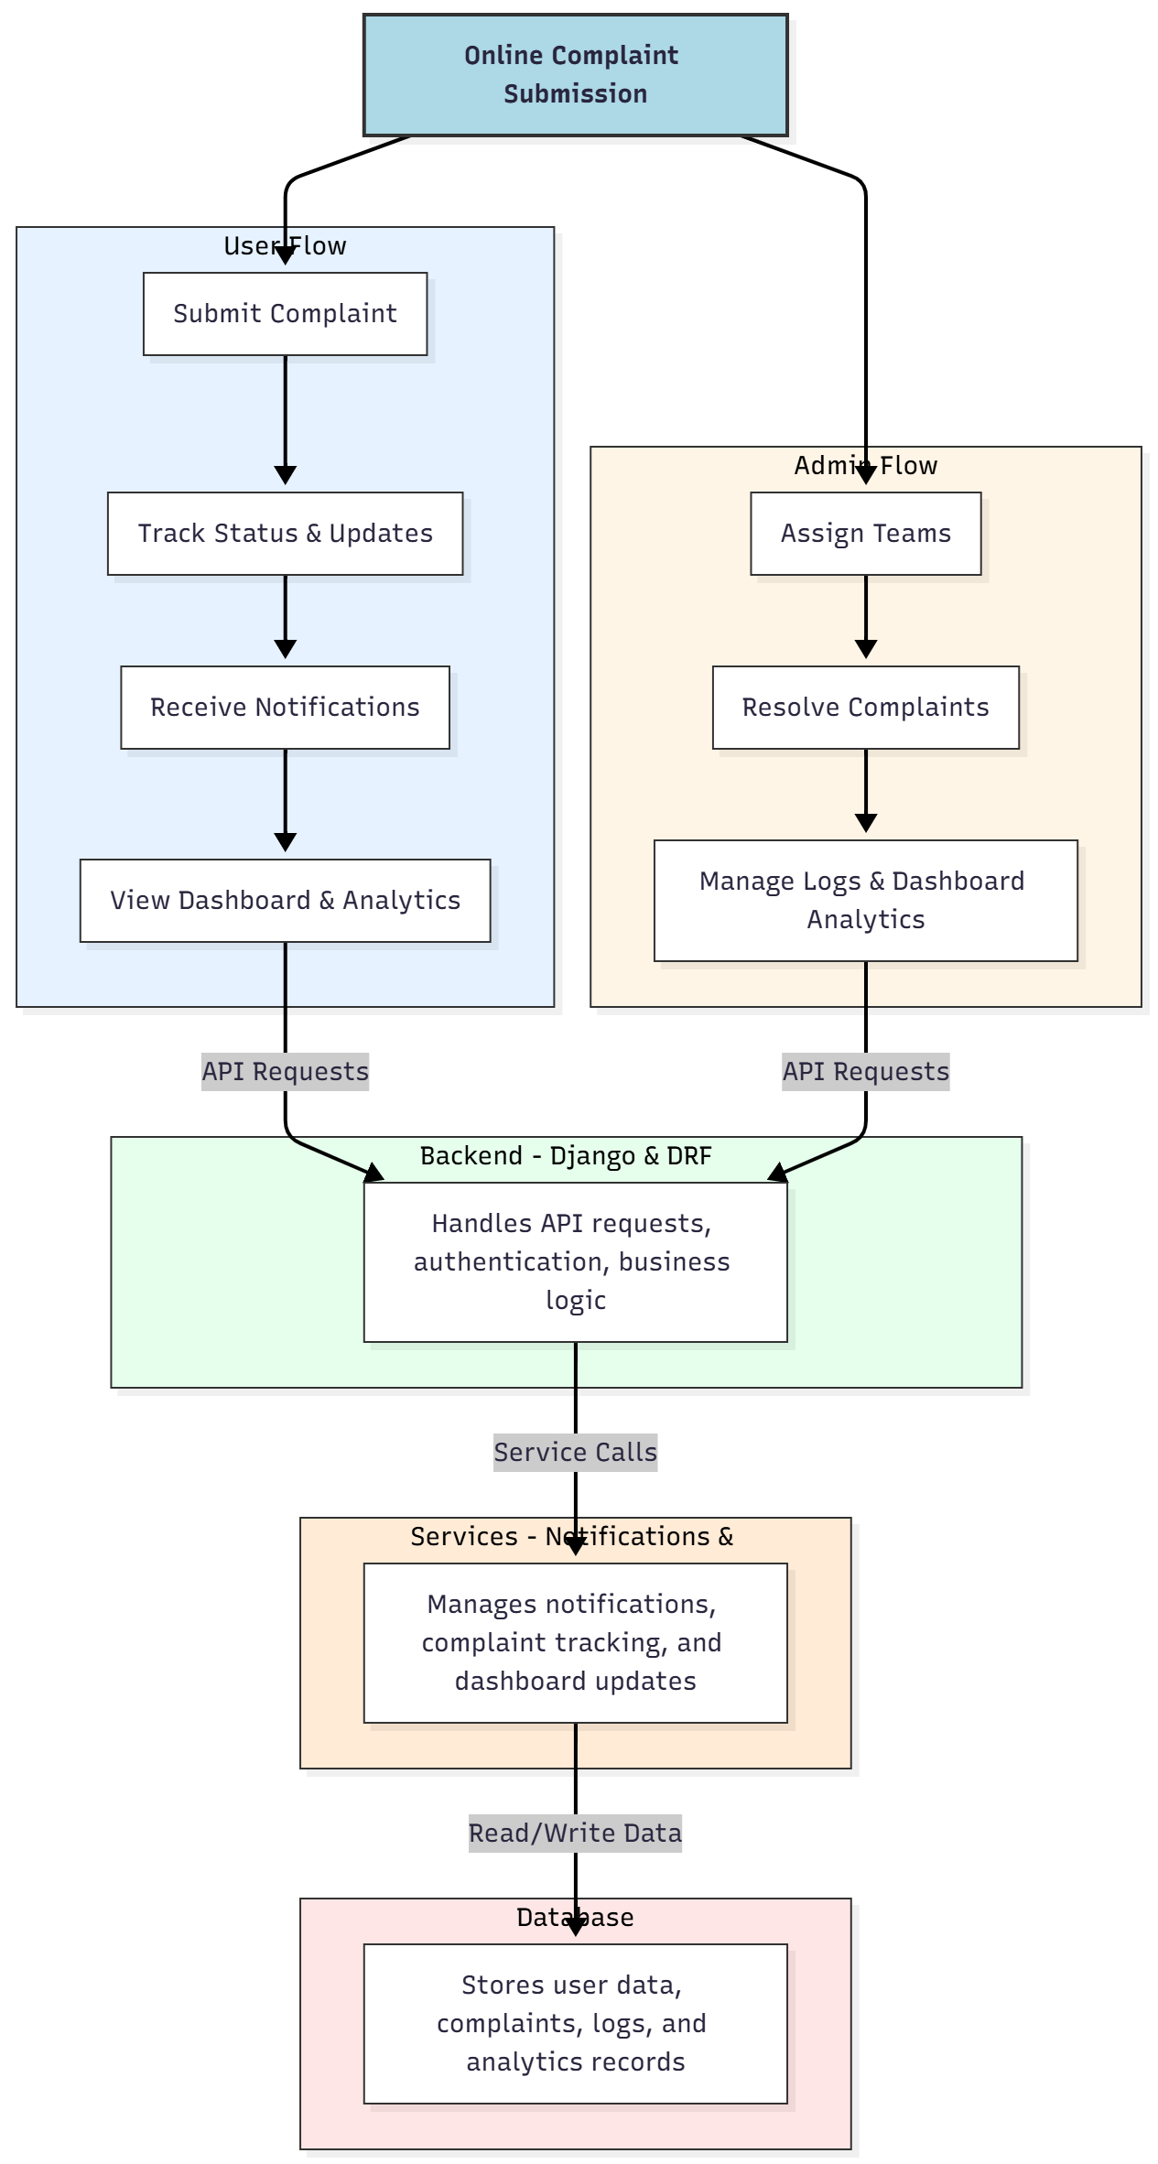

WORKING OF THE PROJECT:
Users log in and submit complaints, track their status through real-time updates, receive notifications, and view dashboards for analytics. The backend manages authentication, business logic, and API requests, while services handle notifications, tracking, and dashboard updates. Administrators can assign teams, resolve complaints, manage logs, and analyze complaint trends via dashboards. This ensures efficient complaint management, timely resolution, and complete accountability..

SOFTWARE REQUIREMENT:
- Backend:
  - Python 3.x
  - Django
  - Django REST Framework
  - SQLite/PostgreSQL
- Frontend:
  - Node.js and npm
  - React.js
  - Axios
- Development Tools:
  - Visual Studio Code
  - Postman (for testing APIs)
  - Git/GitHub (for version control)
- Server/Deployment (Optional):
  - Gunicorn, Nginx, or Heroku/AWS for hosting

ADVANTAGES OF THE PROJECT:

• Simplifies complaint submission and tracking
• Real-time status updates and notifications
• Efficient issue resolution via team assignments
• Centralized logs and dashboard analytics
• Enhances transparency and accountability
• Reduces delays and lost complaints
• Web-accessible platform from multiple devices
• Provides performance metrics for administrators

APPLICATIONS OF THE PROJECT:
• Housing societies and apartment complexes
• Utility service providers
• Municipal complaint management
• Corporate service desks
• Customer service and grievance redressal
• Web-based complaint dashboards
• Issue tracking and notification management
• Analytical reporting of complaint trends

REFERENCES:

- Django REST Framework Documentation — Django Software Foundation. Django Documentation. Available: https://docs.djangoproject.com/
- Django REST Framework. DRF Documentation. Available: https://www.django-rest-framework.org/
- React. React Official Documentation. Available: https://reactjs.org/docs/getting-started.html
- Redux. Redux Documentation. Available: https://redux.js.org/introduction/getting-started
- PostgreSQL Global Development Group. PostgreSQL Documentation. Available: https://www.postgresql.org/docs/
- MySQL. MySQL Reference Manual. Available: https://dev.mysql.com/doc/
- Git. Git Documentation. Available: https://git-scm.com/doc
- Node.js. Node.js Documentation. Available: https://nodejs.org/en/docs/
- Axios. Axios Documentation. Available: https://axios-http.com/docs/intro
- Socket.io Documentation – https://socket.io/docs/

